[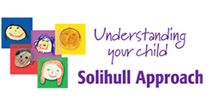](http://www.solihullapproachparenting.com/) **Would you like to better understand your child’s development and behaviour?**

The group is based on an approach developed in Solihull that research has shown to be helpful to parents and has improved their children’s behaviour.

**We will explore issues together such as:**

* **Having fun together**
* **How children develop**
* **Exploring feelings**
* **Behaviour difficulties**
* **How to recover when things go wrong**
* **Communicating with your child**
* **Parenting styles**
* **Sleep patterns**
* **Anger and temper tantrums**

**Venue**: Whitton Clinic, Meredith Road, Ipswich, IP1 6ED

**Time:** 12:30am – 2:30am Refreshments Provided

**Starts**: Wednesday October for 10 weeks

(With a break for half term Wednesday 26h October)

**bookings to the county parenting team can now be made through Suffolk’s online Portal:**

<https://earlyhelpportal.suffolk.gov.uk/web/portal/pages/home>

Professionals with access to EHM & LCS can book a family to a parenting course directly through Liquid Logic, completing a quick standalone form. This form can be started from the basic demographics page of the child’s record on EHM.